**CHAPTER 3**

**DESIGN AND CALCULATION OF THE HUMANOID ROBOT**

**3.1 Anthropometric data for the human body:**

“Antro” means human body and “metric” means measurement, it is combined to gather Anthropometric data. Anthropometry is the science concerning the measurement of human body dimensions for making a human-structure body and products. The designer and engineers use the anthropometric data to reduce error and get the perfect shape and size of the human body using this data depending upon the continent which they are dealing with. Anthropometric human body data resolve the issue of non-statistic body dimensions which is required to design any component related to the human body [38].

**3.2Diagram of the robot**

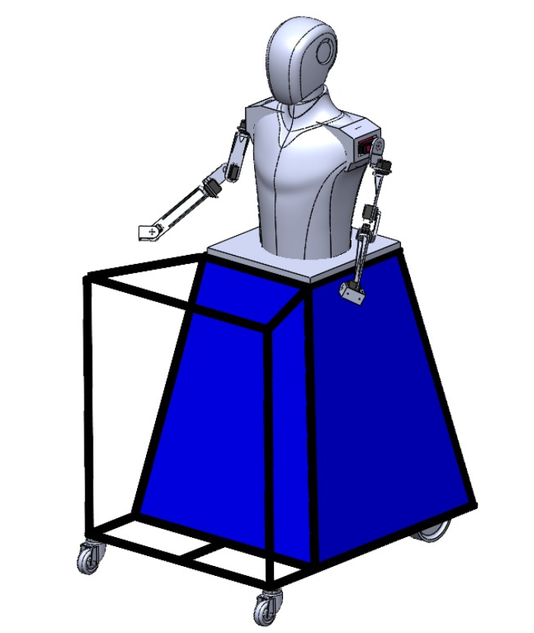As shown in Figure 3.1 CAD Model of humanoid robots requires Human body dimensions to design. It depends on the continent and structure of the design. In design, the various dimensions of Head, body, and arm dimensions are collected from the Anthropometric data sheet.

Anthropometric dimensional data for the human body help to study a human various body parts' movement or motion like a 2 DOF planar limb movement and horizontal plane and precise motion of shoulder and elbow joints. The mechanical linkage lets the user make combined extension and flexion movements of the shoulder and elbow joints to reach specific targets in the horizontal plane. The linkage is modifiable to align its high-quality servo motor joints with the centers of rotation of the shoulder and elbow joints.

Figure 3.1 CAD Model of Robot

**3.3Head dimensions**

When incorporating anthropometric data into the design of a robot head, it's essential to leverage key human anatomical measurements for both practical and aesthetic purposes. These measurements encompass the head circumference, face width, and height, which determine the overall size and proportions of the robot's head. Additionally, details such as interpapillary distance guide the correct placement of the eyes, while nose dimensions and mouth width contribute to realistic facial features. Considering ear size and position relative to the head is also crucial for a lifelike appearance. These anthropometric insights provide a foundation for creating a robot head that mirrors human proportions effectively, ensuring it appears authentic and functions appropriately in various contexts. Tailoring these measurements to specific design objectives and ergonomic requirements is important, particularly if the robot head will engage closely with humans or perform specialized tasks requiring precise spatial considerations [38].

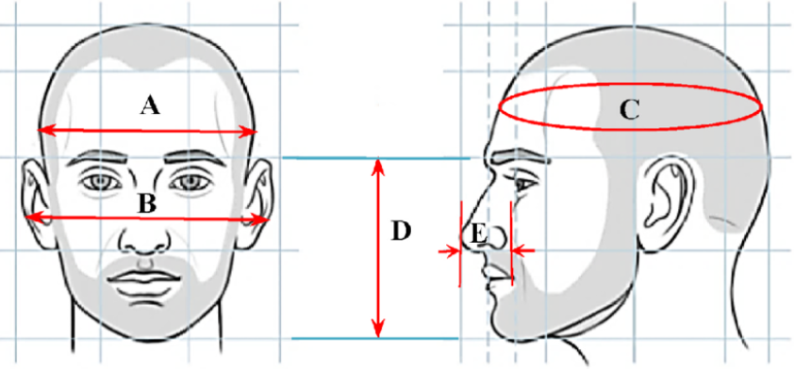Figure 3.2 Anthropometric Measurements of Human Head [39]

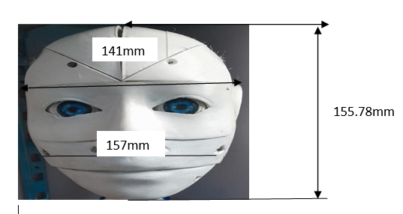

Figure 3.3 Robot Head Dimension [39]

**Table 3.1 Table of anthropometric data dimensions of the Human Head [39]**

|  |  |  |  |  |
| --- | --- | --- | --- | --- |
| **Serial Name** | **Section Name** | **Mean(mm)** | **Min(mm)** | **Max(mm)** |
| A | Head Breadth (Front head) | 155.1 | 141.0 | 167.12 |
| B | Ear-to-Ear Distance | 175.23 | 155.78 | 180.56 |
| C | Circumference (Horizontal perimeter of the head) | 570.54 | 582.3 | 541.02 |
| D | Length (Middle of the forehead to chin) | 157.23 | 142.89 | 168.35 |
| E | Height of the Nose | 32.13 | 29.39 | 33.24 |

Anthropometric measurements of the human head deal with the measurement of Circumference (horizontal perimeter of the head), Head Breadth (The maximum bilateral

distance between the right and left sides of the head.), and length (Middle of the forehead to chin), Ear to Ear Distance, and Height of the nose. The study is done on fifty people of different ages, and the value of the measurements is also shown in Table

**3.4 Anthropometric data of mid-body (Shoulder, Arms, Forearm, Sleeve)**

Anthropometric data encompasses various measurements that provide insights into human body proportions and dimensions. These measurements include Forearm-Forearm Breadth, which denotes the width of the forearm at a specific point, typically near the elbow joint. Forearm-hand length measures the distance from the elbow to the tip of the hand, revealing the forearm's length relative to the hand. Wrist length indicates the segment length between these joints along the forearm. Lower Arm and Upper Arm Lengths specify the lengths of these respective arm segments, crucial for understanding limb proportions. Shoulder-Waist Length measures from the highest shoulder point to the natural waistline, reflecting vertical upper body dimensions. Lastly, the Sleeve Inseam, important in garment design, measures the sleeve length from the armpit to the cuff, ensuring proper fit and comfort. These anthropometric measurements are vital across disciplines such as ergonomics, fashion design, and anthropometry studies, enabling the creation of products and environments that cater to diverse human body sizes and shapes.

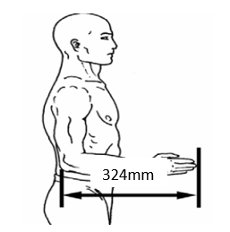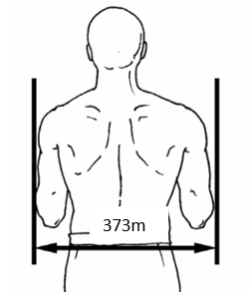

Figure 3.4Forearm-Forearm Breadth [40] Figure 3.5 Forearm-Hand Length [40]

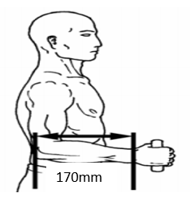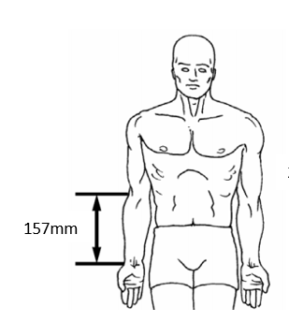

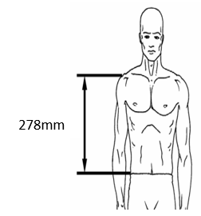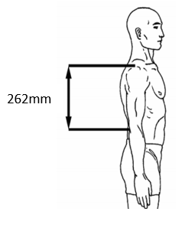Figure 3.6 Elbow-Wrist Length [40] Figure 3.7 Lower Arm length [40]

Figure 3.8 Upper Arm Length [40] Figure 3.9 Shoulder-Waist Length [40]

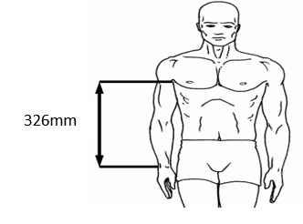

Figure 3.10 Sleeve Inseam [40]

**Table 3.2Table of anthropometric data dimensions Mid Body (Shoulder, Arms, Forearm, and Sleeve) [40]**

|  |  |  |  |  |  |  |  |
| --- | --- | --- | --- | --- | --- | --- | --- |
|  | Forearm-Forearm Breadth(mm) | Forearm-Hand Length (mm) | Elbow-Wrist Length(mm) | Lower Arm  (mm) | Upper Arm Length(mm) | Shoulder-Waist Length(mm**)** | Sleeve Inseam  (mm) |
| Mean | 468.5 | 442.9 | 262.5 | 234.4 | 311.9 | 351.5 | 443.3 |
| Std. Deviation | 34.7 | 23.4 | 15.4 | 15.5 | 16.7 | 22.8 | 29.5 |
| Minimum | 373 | 324.0 | 170.0 | 157.0 | 262 | 278 | 326 |
| Maximum | 609 | 546.0 | 334.0 | 312.0 | 370 | 442 | 553 |

For the mid body of robot for designing the data extract from the Asian anthropometric data of male body. Comparing male body size and shape with the female body the male body have simple body shape and size not like female body have the complicated and many curvy shape and lots of measurements come. The above table is anthropometric data dimensions of male mid body. The male body of anthropometric data offers advantages for robots needing size, strength, and a larger work envelope.

**3.5 Manufacturing**

Manufacturing is the main step to be followed to develop the service robot. Manufacturing transforms the materials into the finished components of the robot, ready to assemble. It can be said that, manufacturing is the backbone and crucial process in the development of the robot. The main procedure of manufacturing the service robot imbibes 3D printing and FRP.

**3.5.1 3D printing**

It is also known as additive manufacturing, where a three-dimensional object is created using CAD model. It tremendously gained importance in the engineering field because of its high benefits. It provides design freedom, individualization and easy execution of the ideas. Because of 3d printing, prototype can be developed faster, it also enables customization and improvement in the quality of the product it prints. It is easy to print complex geometry with high precision and accuracy. The process of 3D printing includes the CAD design of the model, extracting stl file, selecting the material, choosing the parameters, creating the code and building the product. The printer Creality ender 3 is used in the project to print the parts of the robot as this is the most popular and affordable printer. It has gained widespread importance because of its combination of quality construction and decent print volume.

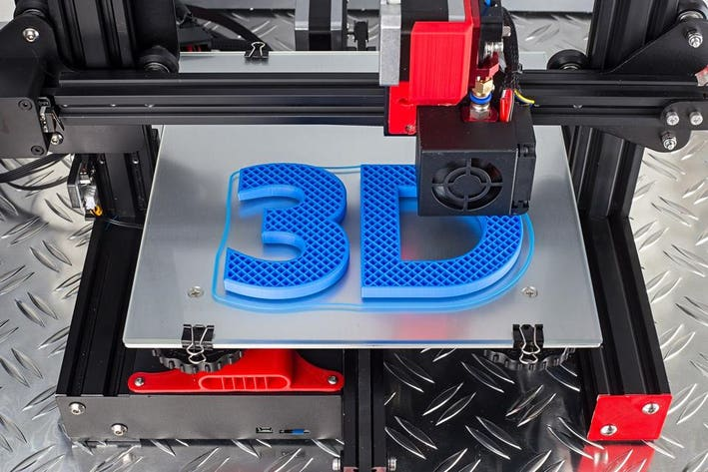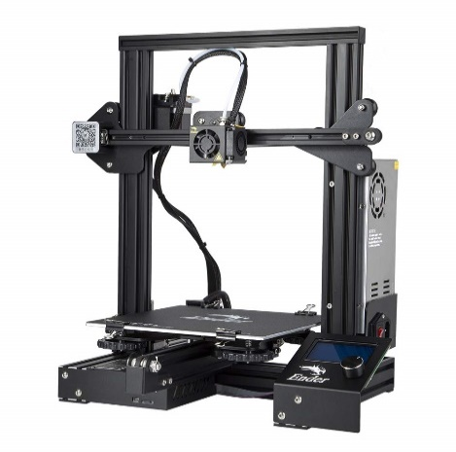

Figure 3.11 3D printing [41] Figure 3.12 Creality 3 3D printer [42]

The humanoid service robot project's integration of 3D printing provides variety in prototypes, allowing for quick component iteration and customization. It can optimize both functionality and aesthetics by customizing parts to the robot's specific needs by utilizing 3D printing technology. In the end, 3D printing allows us to design a humanoid service robot that can be customized to meet the requirements of various users.

**3.5.2 Robot Head**

The head part of the robot is 3D printed. It is divided into small parts so that the parts are properly printed with accuracy. And made easy to assemble with nuts and bolts to resemble a human head. The various parts are lower back, mouth, eyeglass, forehead, side ear support, mouth, jaw as shown in fig. [3.12] and top fullback, top skull left, top skull right, as shown in fig.[3.13].

The files with the CAD models are converted to .stl files. After converting the file, it is transferred to machine and the machine set up is done with proper parameters for the build process. The material selected to print the parts of the head is PLA (Polyactic acid) filament due to its favorable properties such as high strength, low cost and ease of printing. Building the part continues layer by layer. 20% infill density was chosen to balance structural strength and material efficiency with the layer height of 0.2mm. The printing process is carried out on the Creality ender 3 3D printer. Once the build is complete it undergoes post processing of surface finishing by sandpapering and applying an epoxy layer on it.

Later the different parts of head are assembled together to get the required shape of the head of the service robot using M3 nuts and bolts.

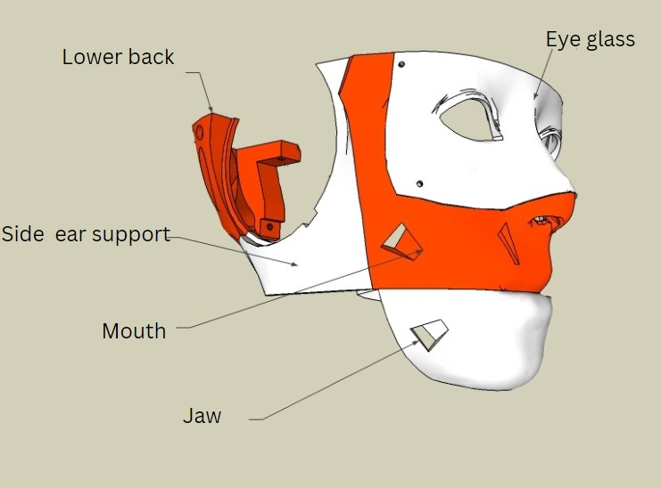

Figure 3.12 Parts of face [43]

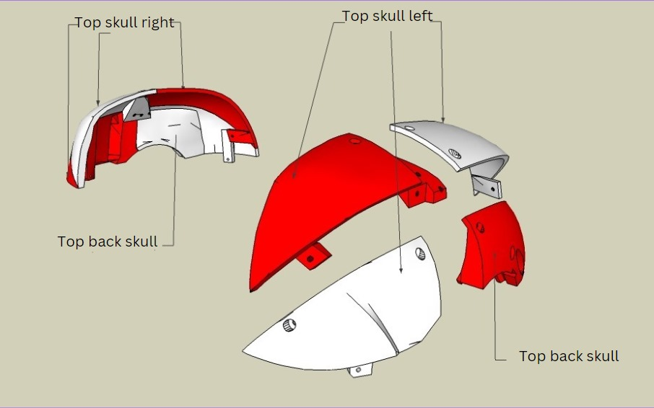

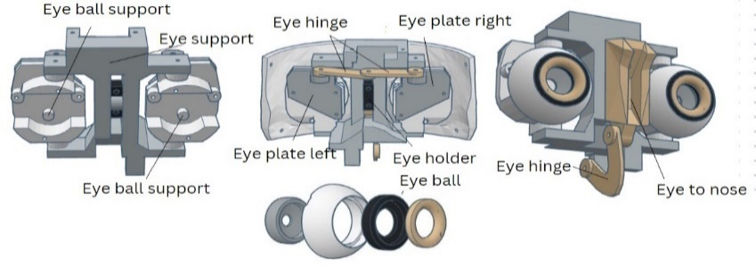 Figure 3.13 Parts of the head [43]

Figure 3.14 Parts of the eye [43]

As shown in the figure. 3.14 above, the eye components are printed accordingly. It constitutes various parts to be assembled like eye hinges, left and right eye plates, eyeballs, eyeball support, eye to nose, eye holder. These are separately printed and the eyes are painted to look to a human eye. The parts undergo the post processing techniques of sandpapering for the smooth finish and its proper functioning. Later the eye parts are assembled using M3 nuts and bolts carefully.

**3.5.3 Arm**

The arm is of 5-degree of freedom each featuring 5 rotary motions. Using the 3D printing technology the arms are printed. The design includes upper arm (biceps), forearm and wrist with shoulder joint, elbow joint and wrist joints for achieving several range of motions. The arm was designed using the solid works software. PLA filament was selected for its material strength with 5% infill chosen to optimize the weight. The 3D printing process was conducted on a Creality 3 3D printer with layer height of 0.3mm. each joint consists servo motors, one with the shoulder joint motor of 60kgcm, another 2 motors of biceps and elbow joint motors of 15 kg-cm and the other two motors for wrist and fore arm rotation motors of 10kgcm.

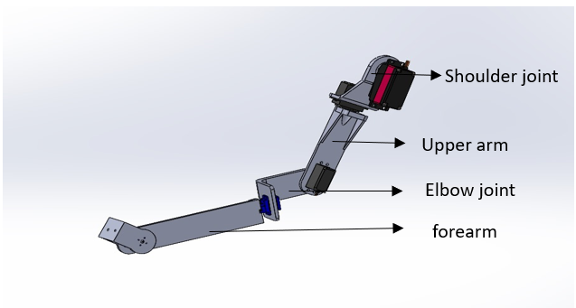

Figure 3.15 Parts of Hand

Assembly involved securing the joints with screws and ensuring the proper alignment for smooth motion. Manufacturing began with the creation of digital 3D model of arms. Later G-code was generated and the parts of the arm were printed carefully. After printing is completed, the parts are aligned properly and assembled with nuts and bolts. As shown in fig[3.15] the parts of arm consist of the shoulder joint part which is first printed and then the upper arm, sequentially elbow joint, and forearm are printed.

**3.5.4 Torso**

The mid body of the robot is the part that will resemble human’s chest and abdomen. It is manufactured using FRP (Fiber reinforced plastic). FRP is a composite material made of a polymer matrix reinforced with fibers. Fibers are usually glass, carbon, aramid or basalt. Others are also used such as paper, wood, boron or asbestos have been used. It is essential to maintain and to strengthen the existing infrastructure. It is the best suited for any design program that demands weight savings, precision and simplification. Hence, the body is made of FRP. Achieving human-like aesthetic is crucial for enhancing robot’s ability to interact with humans.

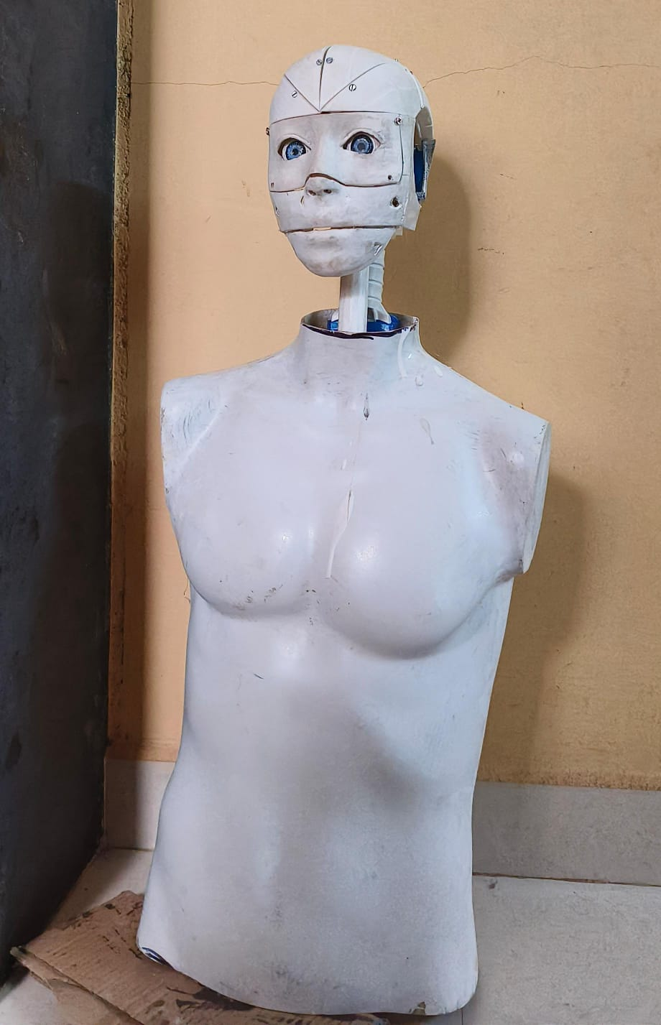

Figure 3.16 Mid-body of the robot

The first step in the fabrication process was to create a precise clay sculpture that captured the expressions and anatomical details unique to a human face and body. After that, a mold release agent was applied to this sculpture to stop the adhesion of the next materials. To ensure precise replication of the fine features, layers of silicone rubber were applied around the sculpture to produce a negative mold. The negative mold was filled with layers of fiberglass cloth that had been appropriately shaped. The fiberglass cloth was then saturated with polyester resin combined with a catalyst, creating a robust and long-lasting composite. The composite was carefully removed from the mold after a suitable amount of time had elapsed for hardening, exposing the modeled human shape. The finishing touches, which included painting for realism and sanding for smoothness, were applied to achieve the desired appearance.

**3.5.5 Lower Body**

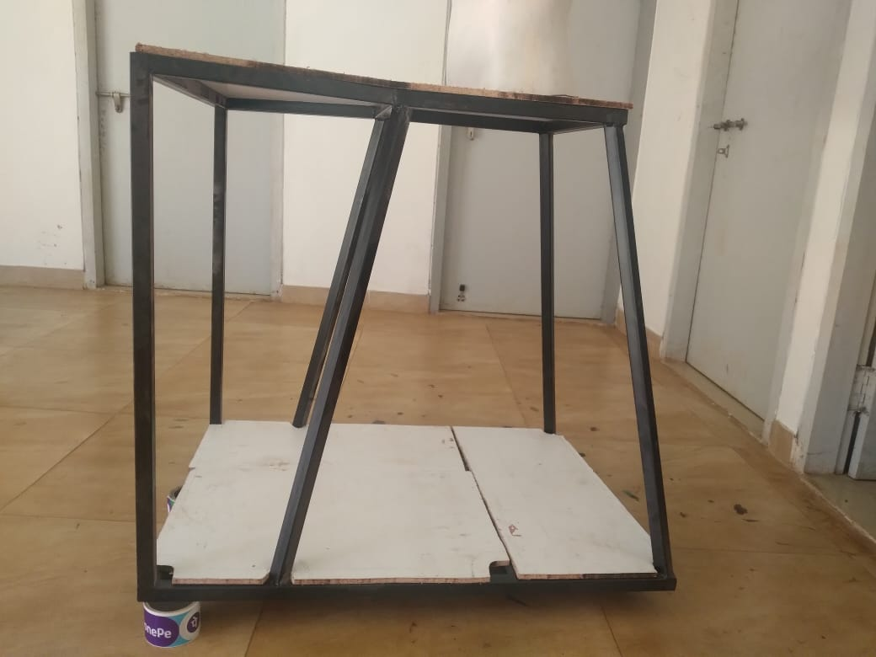The objective of the fabrication of the lower body is to provide structural support and stability while accommodating essential components. The trapezoidal prism shape was chosen for its ability to house internal components efficiently and distribute weight evenly. Mild steel beams were used in the fabrication process, along with a variety of hand tools like drilling, and grinding machines for shaping and cutting. Arc welding has been done to join the beams. The lower body's trapezoidal prism shape was created by welding together mild steel components. Because MIG welding is so versatile and can create strong, long-lasting welds with little distortion, it is one of the most welding processes used. The design stage of the construction process started with conceptualization of the shape and the beams were formed by the design. After the beams were put together and oriented in the correct positions, welding was done to secure them.

Figure 3.17 Lower body

**3.6 Structural Design of Lower Half**

The project has a cone-shaped lower half rather than normal human-like legs because of the complexity of the calculation and centroid verification methods. The cone structure provides the robot stability to hold the excess weight of the upper body just in case and will allow easy and low-cost maintenance and build materials to structure it. The hollow characteristic given to the robot will give sufficient space to fit the other important connections like the battery, and electronic components required for the robot to run. The overall performance of the robot will be enhanced due to the hollow and rigid nature of the frame used in the construction of the lower body thus providing a low-cost alternative to the lower body construction.

**3.6.1 Calculations: CAD data**

Using the simulation capability of CAD modeling software, the stability data of the robot can be easily obtained. Important parameters like the center of mass and the moment of inertia are provided by this feature. The stability and functionality of the robot depend on these characteristics. Furthermore, the manufacturing process is facilitated by the simulation data, which provides exact measurements and insights required to create the robot precisely.

Center of mass: (millimeters)

X=-98.94

Y=329.07

Z=0.00

Principal axes of inertia and principal moments of inertia: (grams* square millimeters) Taken at the center of mass.

|  |  |  |  |
| --- | --- | --- | --- |
| Lx | 0.01 | 1.00 | 0.00 |
| Ly | -1.00 | 0.01 | 0.00 |
| Lz | 0.00 | 0.00 | 1.00 |

|  |  |
| --- | --- |
| Px | 287862575.80 |
| Py | 391850586.30 |
| Pz | 393904421.78 |

Moments of inertia: (grams* square millimeters)

Taken at the center of mass and aligned with the output coordinate system. (Using positive tensor notation.)

|  |  |  |
| --- | --- | --- |
| Lxx = 391847381.91 | Lxy = 577245.45 | Lxz = 798.63 |
| Lyx = 577245.45 | Lyy = 287865780.25 | Lyz = 1129.17 |
| Lzx = 298.63 | Lzy = 1129.17 | Lzz = 393904421.72 |

Moments of inertia: (grams square millimeters)

Taken at the output coordinate system. (Using positive tensor notation.)

|  |  |  |
| --- | --- | --- |
| Lxx =933296599.78 | Lxy =-162214126.71 | Lxz = 338.15 |
| Lyx =-162214126.71 | Lyy =336810408.80 | Lyz = 997.74 |
| Lzx =338.15 | Lzy =997.74 | Lzz =984298268.14 |